**Project Overview**

A jewelry company wants to put in a bid to purchase a large set of diamonds, but is unsure how much it should bid. In this project, you will use the results from a predictive model to make a recommendation on how much the jewelry company should bid for the diamonds.

**Project Details**

A diamond distributor has recently decided to exit the market and has put up a set of 3,000 diamonds up for auction. Seeing this as a great opportunity to expand its inventory, a jewelry company has shown interest in making a bid. To decide how much to bid, the company’s analytics team used a large database of diamond prices to build a linear regression model to predict the price of a diamond based on its attributes. You, as the business analysts, are tasked to apply that model to make a recommendation for how much the company should bid for the entire set of 3,000 diamonds.

The following diagram represents the analysis at a high level. Since the model is already built, your analysis will focus on the right side of the diagram.

[[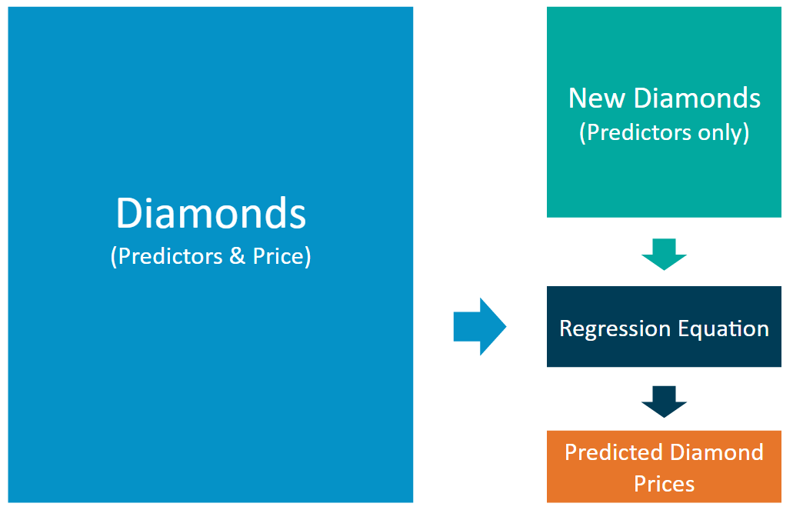](https://classroom.udacity.com/nanodegrees/nd008-mena-connect/parts/213e4b1c-b120-4641-ac29-1eeabfe95965/modules/a18044bc-d0a2-4dfb-9b7f-9c35e2cd149d/lessons/bb2ab926-b527-4ead-97b8-e2ca1e7aa7b7/concepts/d8abb9a7-488e-4f7d-bd9d-77e85b5ebcbb)](https://classroom.udacity.com/nanodegrees/nd008-mena-connect/parts/213e4b1c-b120-4641-ac29-1eeabfe95965/modules/a18044bc-d0a2-4dfb-9b7f-9c35e2cd149d/lessons/bb2ab926-b527-4ead-97b8-e2ca1e7aa7b7/concepts/d8abb9a7-488e-4f7d-bd9d-77e85b5ebcbb)

The linear regression model provides an equation that you can use to predict diamond prices for the set of 3,000 diamonds. The equation is below:

**Price** = -5,269 + 8,413 x **Carat** + 158.1 x **Cut** + 454 x **Clarity**

**Step 1 – Understand the data:** There are two datasets.

* **diamonds.csv** contains the data used to build the regression model.
* **new_diamonds.csv** contains the data for the diamonds the company would like to purchase.

[[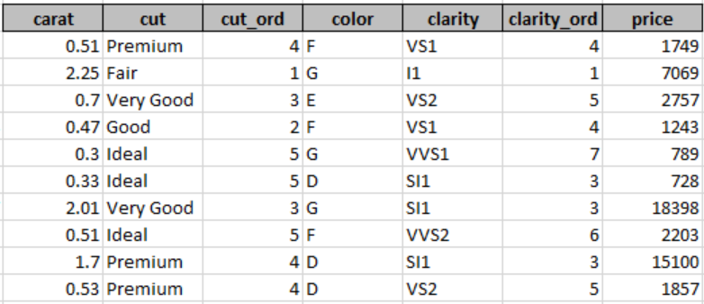](https://classroom.udacity.com/nanodegrees/nd008-mena-connect/parts/213e4b1c-b120-4641-ac29-1eeabfe95965/modules/a18044bc-d0a2-4dfb-9b7f-9c35e2cd149d/lessons/bb2ab926-b527-4ead-97b8-e2ca1e7aa7b7/concepts/d8abb9a7-488e-4f7d-bd9d-77e85b5ebcbb)](https://classroom.udacity.com/nanodegrees/nd008-mena-connect/parts/213e4b1c-b120-4641-ac29-1eeabfe95965/modules/a18044bc-d0a2-4dfb-9b7f-9c35e2cd149d/lessons/bb2ab926-b527-4ead-97b8-e2ca1e7aa7b7/concepts/d8abb9a7-488e-4f7d-bd9d-77e85b5ebcbb)

Both datasets contain carat, cut, and clarity data for each diamond. Only the *diamonds.csv* dataset has prices. You'll be predicting prices for the *new_diamonds.csv* dataset.

* *Carat* represents the weight of the diamond, and is a numerical variable.
* *Cut* represents the quality of the cut of the diamond, and falls into 5 categories: fair, good, very good, ideal, and premium. Each of these categories are represented by a number, 1-5, in the *Cut_Ord* variable.
* *Clarity* represents the internal purity of the diamond, and falls into 8 categories: I1, SI2, SI1, VS1, VS2, VVS2, VVS1, and IF. Each of these categories are represented by a number, 1-8, in the *Clarity_Ord* variable.
* **Note:** Transforming category variables to ordinal variables like this is not always appropriate, but we’ve done it here for simplicity.

**Step 2 – Calculate the predicted price for diamond:** For each diamond, plug in the values for each of the variables into the linear model (equation). Then solve the equation to get the estimated, or predicted, diamond price. We suggest using a spreadsheet tool like Excel, Numbers, or Google Sheets. You could also do it in Alteryx and/or Tableau if you already have a license. If you don't have a license yet, you'll receive one after your free trial.

**Step 3 – Make a recommendation:** Now that you have the predicted price for each diamond, it’s time to calculate the bid price for the whole set. Note: The diamond price that the model predicts represents the final retail price the consumer will pay. The company generally purchases diamonds from distributors at 70% of that price, so your recommended bid price should represent that.